Buoy System:
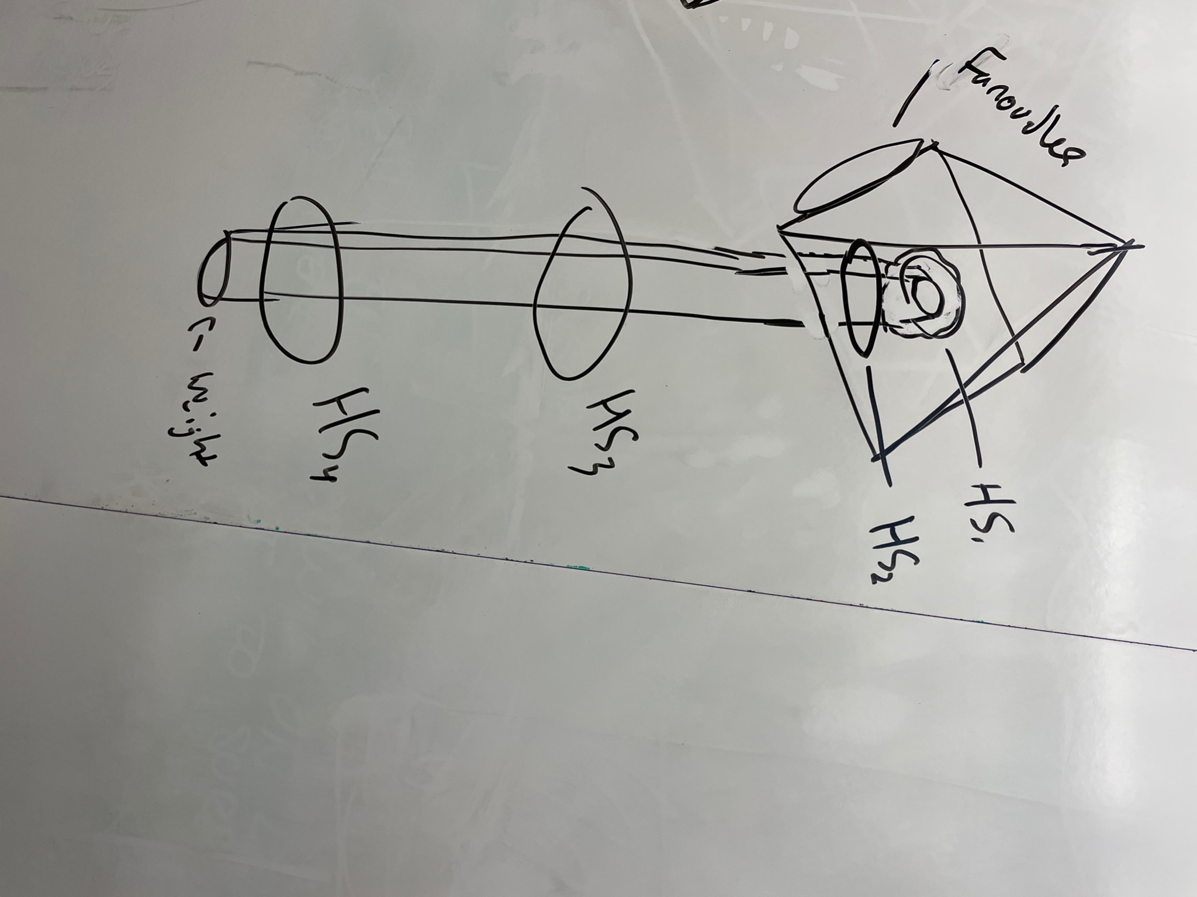

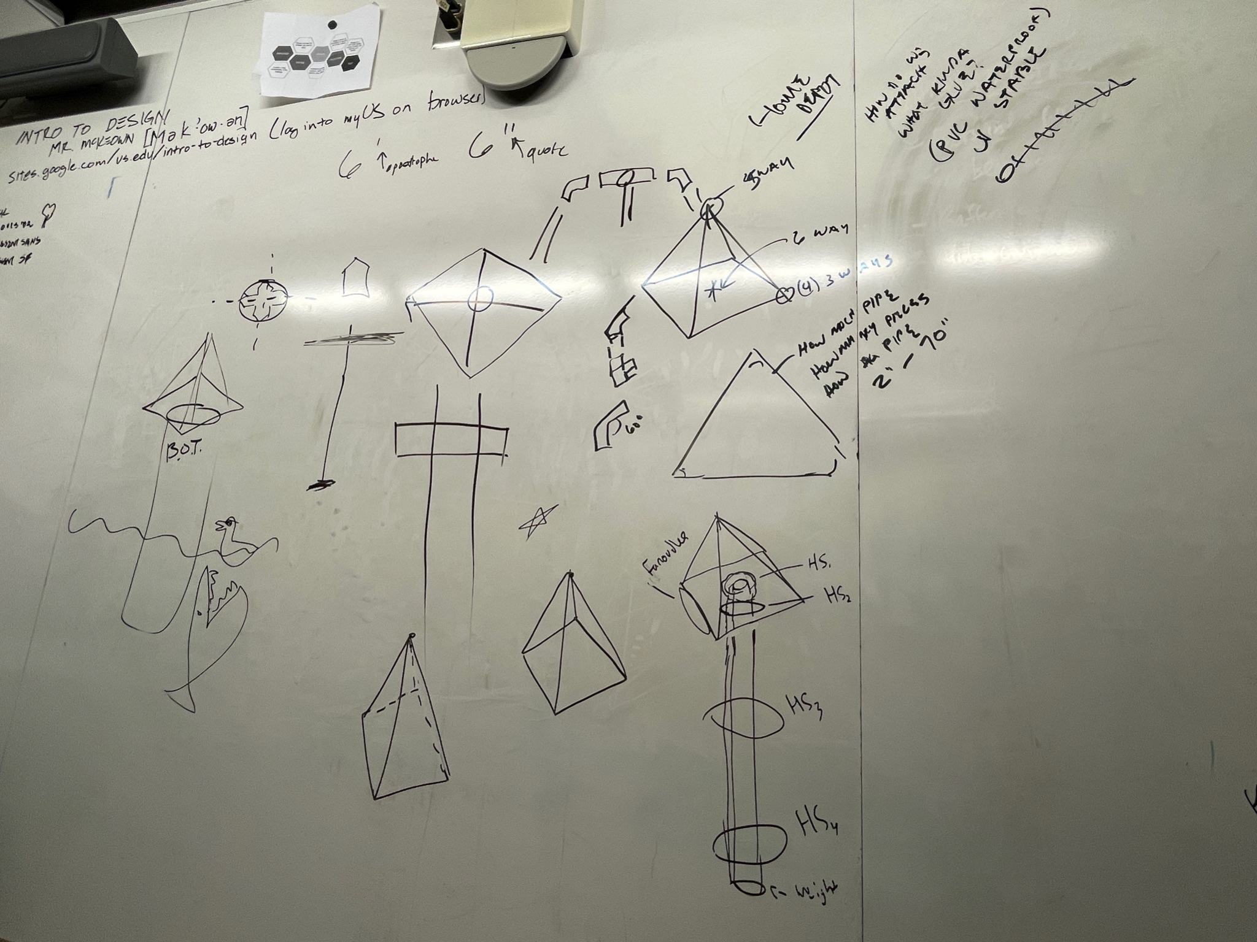

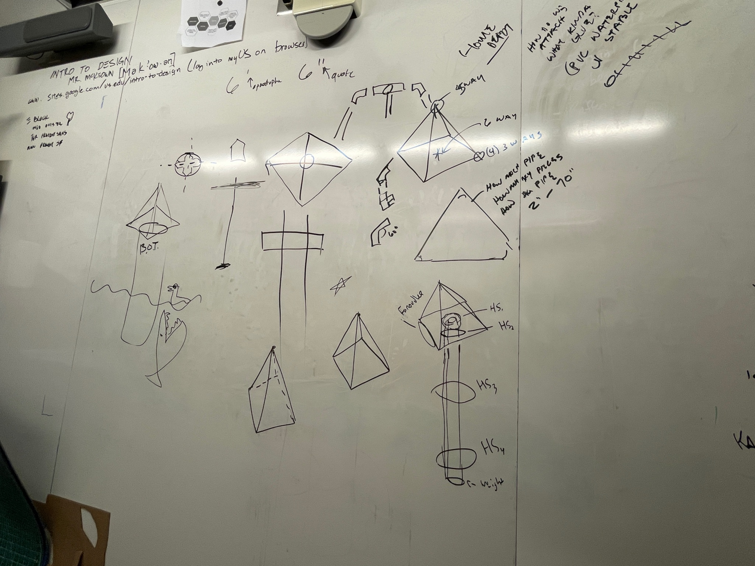

Items we need
Multiply all values by 2
Pool Noodles

Formufit 1-1/2 in. Furniture Grade PVC 5-Way Cross in White (4-Pack) - 1

Charlotte Pipe 1-1/2 in. PVC Schedule 40 S x S x S x S Cross - 1

Charlotte Pipe 1-1/2 in. PVC Schedule. 40 45-Degree S x S Elbow Fitting - 16

JM EAGLE 1 in. x 10 ft. PVC Schedule 40 Plain-End Pipe - 2
1-1/2 in. Furniture Grade PVC 4-Way Tee in White (4-Pack) - 1

Solar Panels:
https://www.amazon.com/dp/B01EXWCPLC/?tag=thewire06-20&linkCode=xm2&ascsubtag=AwEAAAAAAAAAAgI_ BigBlue 3 USB Ports 28W Solar Charger(5V/4.8A Max), Foldable Portable Solar Phone Charger with SunPower Solar Panel

